# College-database management-system

# Project report

# Date:30-04-2017.

# Group members:

# D.padmakara srinivas(U101115FCS079)

# Byreddy Nikhil reddy(U101115FCS070)

# **Challa sadhika(U101115FCS075)**

1. **Chapala sai sowmya(U101115FCS076)**

**Section:S3.**

**Problem statemen**

All the students in the college, go to the library, and the college has only one library,the attributes of the library are book_id,book_name,issue_date.So, the relation is many-one. In the same case, all the students of the college are enrolled in courses, and the condition here is each student should get enrolled in a min. Of 6 courses each. So, here the relation is many to many.Faculty has a time-table, which has the attributes course_id, faculty_name,room,day_and_time, in the same case,students also have a timings,this relation is many to many, while in case of a consideration of a single section it is a one to one relation.Students borrow textbooks from one library, in this case the relation b/w textbooks and students is many to many, in case of librarian to textbooks is one to many.students take up exams, and faculty conducts exams, the relation b/w exams and students and faculty and exams is many to many in both.faculty teaches courses, the relation is many to many.each faculty is associated to a department, that is many to many,faculty should be compulsorily associated to a department,which is total participation.faculty takes up attendance, so the relation is many to many, as there are many classes.it is also a compulsory total participation.Students are living in hostel, hostels are controlled by many wardens so they are many to many between hostels and wardens, and the students living in hostel is an optional choice.Students apply for gate_pass, and wardens approve them, so the relation is many to many, which is a compulsory participation.

# E-rdiagram:

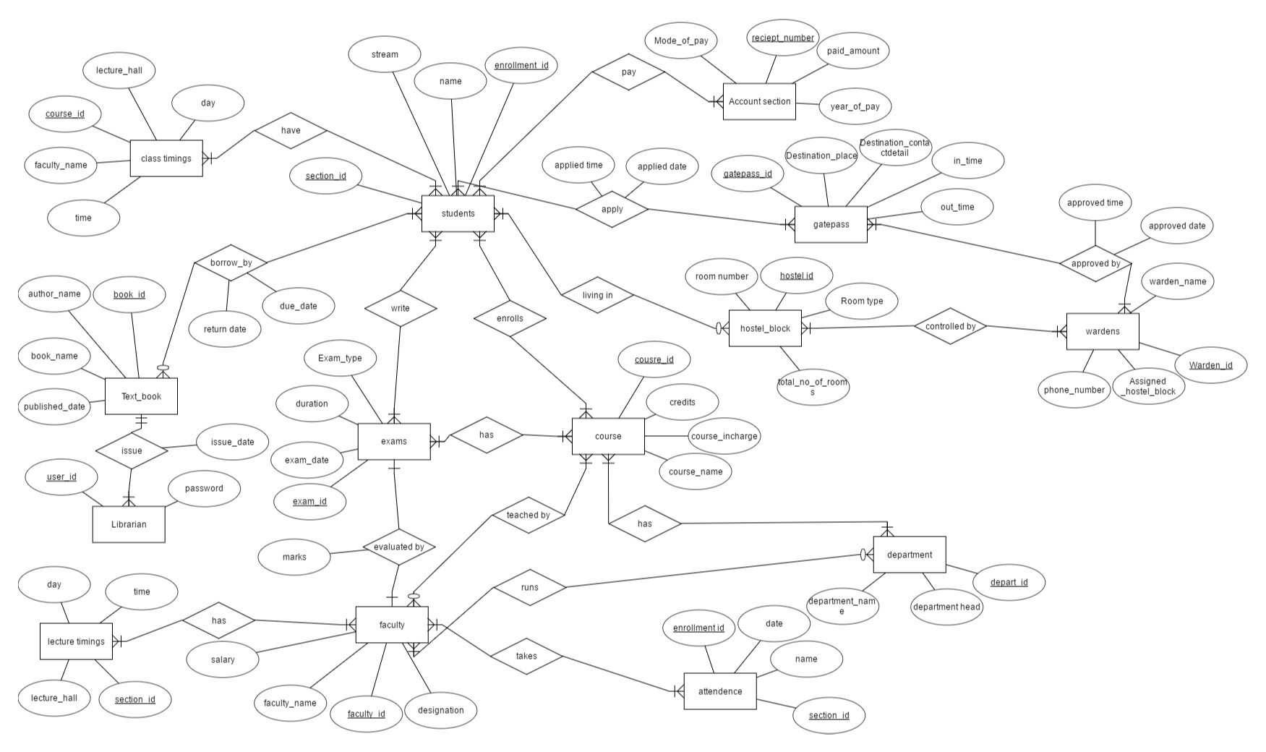

Relational schema: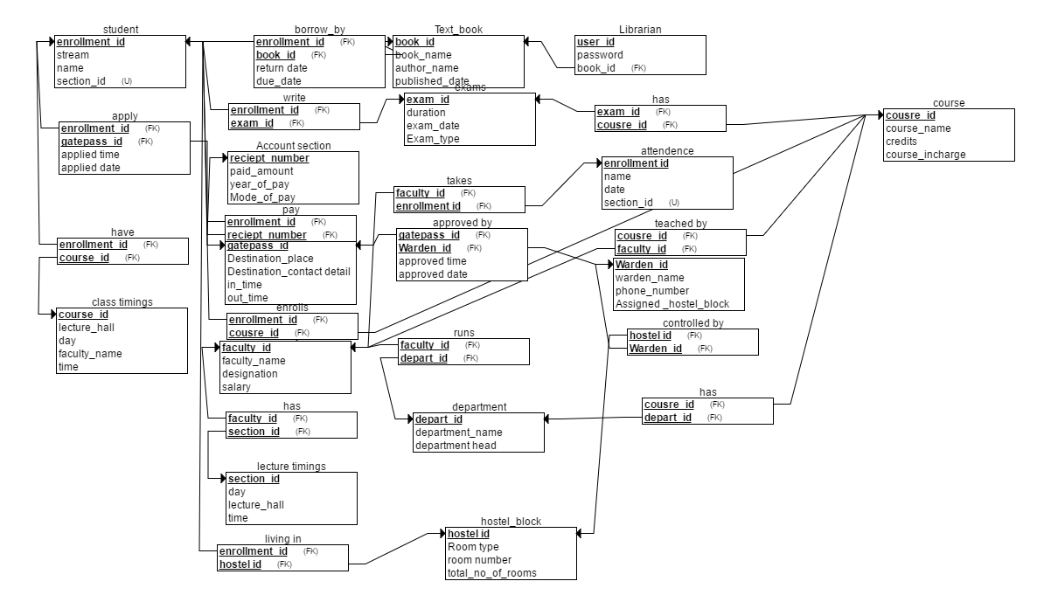

Table schema:-converting er diagram to relational

|  |  |  |  |  |
| --- | --- | --- | --- | --- |
| Entity | | Description | Sql syntax |  |
| students | | It contains students details | Create students(name varchar(30),section_id varchar(20),stream varchar(20),enrollment_id varchar(30),primary key(enrollment_id)); |  |
| Class_timings | | It contains the class timings of the student | Create class_timings(facultyname varchar(30),time int(10),course_id varchar(20),lecture_hall varchar(30),day varchar(20),primary key(course_id)); |  |
| Text_book | | It contains the details of the subject. | Create text_book(book_idvarchar(30),author_name varchar(30),book_name varchar(30),published_date int(10)primary key(book_id)); |  |
| exams | | It has details of the exam types of the exams | Create exams(examtype varchar(30),duration int(30),exam_date int(30),exam_id varchar(30),primary key(exam_id)); |  |
| Librarian | | It has details of the librarian | Create librarian(user_id varchar(30),password varchar(30),primary key(user_id)); |  |
| course | | Course details,credits,course in-charge, etc, | Create course(course_id varchar(30),credits int(10),course_in-charge varchar(40),course_name varchar(30),primary key(course_id)); |  |
| Gatepass | | It has details of the outgoing and incoming of the students in the campus | Create gatepass(gatepass_id varchar(30),destination_place varchar(30),destination_contact_detail int(10), in_time int(10),out_time int(10),primary key(gatepass_id)); |  |
| hostelblock | | It has details of the hostel and details | Ceate hostels(room_no int(10),HOSTEL_ID varchar(10),room_type varchar(10),primary key(hostel_id)); |  |
| Account section | | Details of the fee and accounts | Create account_section(mode_of_pay(varchar(10),receipt_no varchar(20),paid_amount int(10),year_of_pay int(10),primary key(receipt_no.)); |  |
| wardens | | Warden details | Create wardens(warden_id varchar(20),phone_no int(10),assigned_hostel_block varchar(10),warden_name varchar(10),primary key(warden_id)); |  |
| Department | | Details of the department | Create department(department_id varchar(30),department_name varchar(30),department_head varchar(30),primary key(department_id)); |  |
| faculty | | Details of the faculty | Create faculty(faculty_id varchar(30),faculty_name varchar(30),designation varchar(100),salary int(10),primary key(faculty_id)); |  |
|  |
|  |
|  |
|  |

Normalization is done for all the tables to 3NF to BCNF and according to functional dependencies by decomposition.

2NF requirements:

All the attributes are must be functionally dependent on primary key.

3Nf requiremnets:

No attribute is transistively dependent on the primary key.

BCNF requiremnts:

CtudNF does not allow dependencies between attributes that belong to candidaeste keys.

BCNF is a refinement of the third normal form in which it drops the restriction of a non-key attribute from the 3rd normal form.

Student table:

Entities used:enrollment_id,stream,name,section_id.

The set of key attributes is={enrollment_id}

FD’s used:Enrollment_id->stream

Enrollment_id->name

Enrollment_id->section_id

Name->section_id

Name->stream

The table is in already 2NF because stream,name,section_id are all dependent on enrollment_id.

The table is not in 3NF because enrollment_id,stream,section_id are transistively dependent.

3NFdecomposition:

1. Move all items involved in transitive dependencies to a new entity.
2. Identify a primary key for new entity.so here section_id become primary key.

So new student table is

New Students(section_id,name,stream)

Primary_key:name;

Original Students(enrollment_id,name)

Primary key: enrollment_id;

Foreign key: name;

The table is in BCNF Normalisation for new entities.

Here no need to decompose it.

Exam table:

Attributes used: exam type,duration,exam_id,exam_date

Primary key:exam_id;

FD’s used: Exam_id->exam type

Exam_id->exam_date

Exam_id->duration

The table is already in 2NF,3NF and BCNF.

Courses table

Attributes used:course_incharge,course_name,credits,course_id

Primary key:course_id;

FD’s used:Course_id->course_name

Course_id->course_incharge

Course_id->credits

Course_name->course_incharge

2NF: The entire table is dependent on course_id(primary key)

3NF:The table is not in 3NF because course_name and course_incharge transistvely dependent.

so new courses table is

new courses(course_name,couse_incharge)

Primary key: course_name;

Original courses(course_name,credits,course_id)

Primary key:course_id;

Foreign _key:course_name;

Textbook table:

Attributes used:book_id,author_name,book_name,published_date

Primary key: book_id;

F.D.’s used:

Book_id->book_name

Book_id->author_name

Book_id->published_date

Book_name->author_name

2NF: all attributes are functionally dependent on primary key.

3NF: since book_name,author_name are transistively dependent.

3NF decomposition:

New Textbook(book_name,author_name)

Primary key:book_name

Textbook(book_id,book_name,published_date)

Primary_key:book_id

Foreign _key: book_name

Now no attribute is transistively dependent.so it is in 3NF as well as BCNF.

Librarian table:

Attributes used: username,password.

Primary_key:username

The table is in 2nF,3NF and BCNF.

Class timings table:

Attributes used: course_id,faculty_name,lecture_hall,day,time

Primary key: course_id;

FD’s used:Course_id->faculty_name

Course_id->lecture_hall

Faculty_name,time,day>lecture_hall

2NF:it is not in 2NF because all attributes are not dependent on primary key.

2NF decomposition:

New class timings table(course_id,faculty_name,lecture_hall)

Primary key:faculty_name

Foreign_key:course_id

Class timings(course_id,day,time)

Primary key:course_id;

So,now it is not in 3NF.

3NF decomposition:

New class_timings(course_id,faculty_name,lecture_hall)

Primary key:course_id;

Foreign_key:lecture_hall;

Class_timings(faculty_name,day,time,lecture_hall)

Primary key: lecture_hall;

So it is not in BCNF.

New class_timings(course_id,faculty_name,lecture_hall)

Primary key:lecture_hall;

Foreign_key:course_id;

Class_timings(course_id,day,time)

Primary_key:course_id;

Account_section table (

mode_of_pay,receipt_number, paid_amount,year_of_pay,Primary key(recepit number);

F.D’s used:

Receipt number->mode_of_pay

Receipt_number->paid_amount

Receipt_number->year_of_pay

The table is in already 2NF,3NF and BCNF.

Faculty table:

Attributes used:faculty_name,faculty_id,salary,designation

FD.s used:

Faculty_id->faculty_name

Faculty_id->designation

Faculty_id->salary

Faculty_name->designation

2NF: The table is already in 2NF because all attributes are dependent on primary key.

3NF:

Faculty name,designation,Faculty_id are transistively dependent.

3NF decomposition:

New Faculty(Faculty_name,designation)

Primary key: Faculty_name

Faculty(Faculty_name,faculty_id,salary)

Primary_key:Faculty_id

Foreign_key:Faculty_name;

So the table is in 3NF decomposition.

This is also called as BCNF decomposition.

lecture timings table

Attributes used:section_id,lecture_hall,day,time

Primary key:section_id;

Fd.s used:

Section_id->lecture_hall

Section_id,Day,time->lecture_hall

2NF: No attribute is dependent on the primary key.

2NF decomposition:

New lecture timings table(sectioqnid, lecture hall);

Primary key: sectionid;

Lecture timings table(sectionid,day,time)

Foreign key: section id;

Primary key:day;

So now these are 2NF,BCNF and 3NF.

Department table:

Attributes used:(department_name,department_head,

department_id)

Primary key:department_id;

F.D’s used:

Department_id->department_head

Department_id->department_name

Department_name->department_head

2NF: The table is in 2NF because all attributes are dependent on the primary key.

3NF: The table is not in 3NF because Deaprtment_name,department_head are transistvely dependent.

3NF decomposition:

New department(department name,department head);

Primary key: Department name;

Department(department name,department_id);

Foreign key: Department_name;

Primary_key:Department_id;

Now the table is in 3NF and BCNF also.

Hostel block table:

Attributes used:Room_number,hostel_id,room_type,

total_no_of rooms

Primary key:hostel_id;

F.d.’s used:

Hostel_id->total_no_of_rooms

Hostel_id->room_type

Room_number->room_type

2NF: The table is in 2NF beacuse all attributes are dependent on hostel_id;

The table is not in 3NF because room_number,room_type are transistively dependent.

3NF decomposition:

New hostel_block(Room_number,room_type)

Primary key:Room_number;

Hostel_block(room_number,total_no_of_rooms,hostel_id)

Primary_key:hostel_id;

Foreign_key:room_number;

Now this is 3NF and BCNF also.

Gatepass_table:

Attributes used: Gatepass_id,destination_place,Destination_contact_detail,in_time,out_time

Functional dependencies:

Gatepass_id->destination_place

Gatepass_id->destination_contact_detail

Gatepass_id->in_time

Gatepass_id->out_time

The table is in 2NF,3NF and BCNf also.

Wardens table:

Attributes used:Warden_name,phone_number,assigned_hostel_block,warden_id)

F.d’s used:

Warden id->warden_name

Warden_id->assigned_hostel_block

Warden_id->phone_number

Warden_name->assigned_hostel_block

Phone_number->warden_name

2NF: entire table is dependent on the primary key.

3NF: the table is not in 3 NF because warden name,assigned hostel block,phone number are transistively dependent.

3NF DECOMPOSITION:

New wardens(warden name,assigned_hostel_block)

Primary key:warden_name;

Wardens2(phone number,warden name)

Primary key:phone number

Foreign_key:warden_name;

Wardens3(warden_id,phone number)

Primary key:warden_id;

Foreign_key:phone number;

SQl sample outputs:

1. Table students

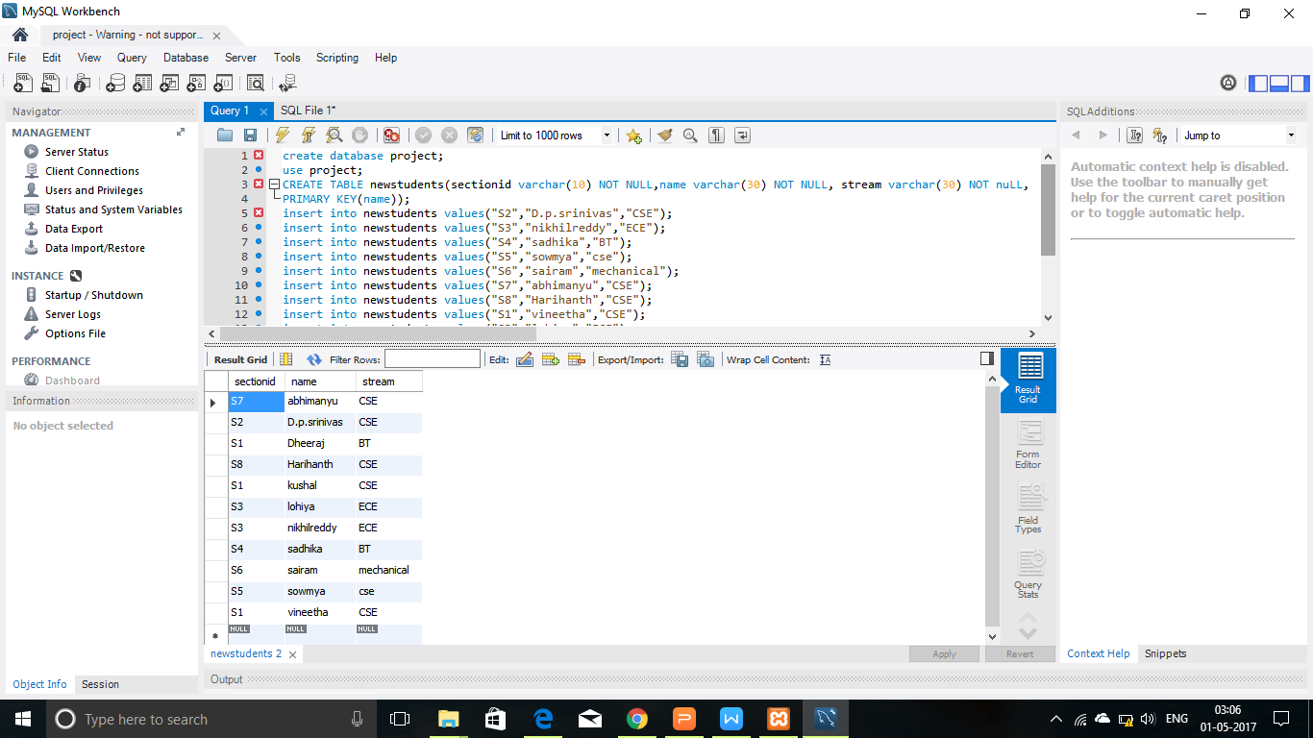

1. Table class_timings
2. 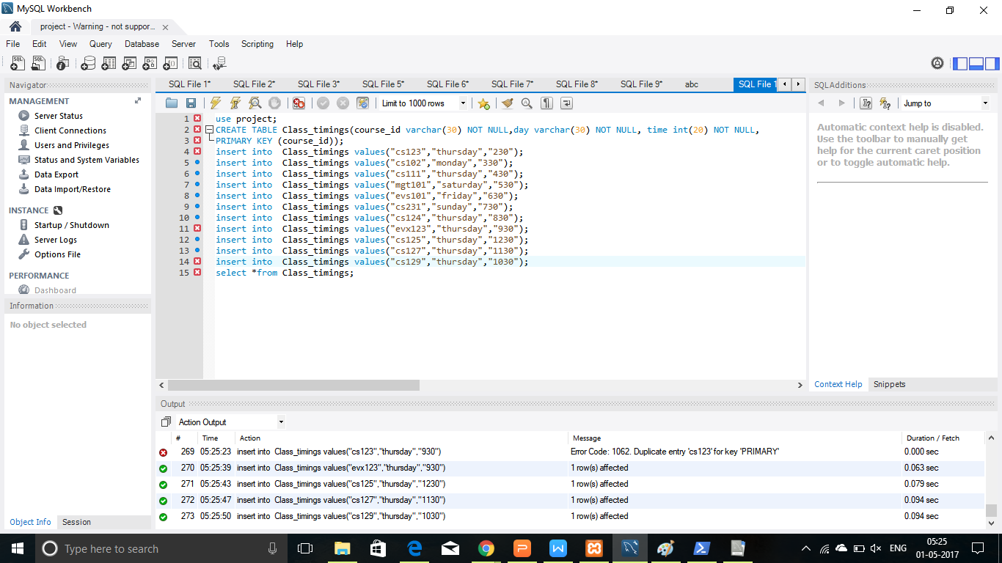

Output: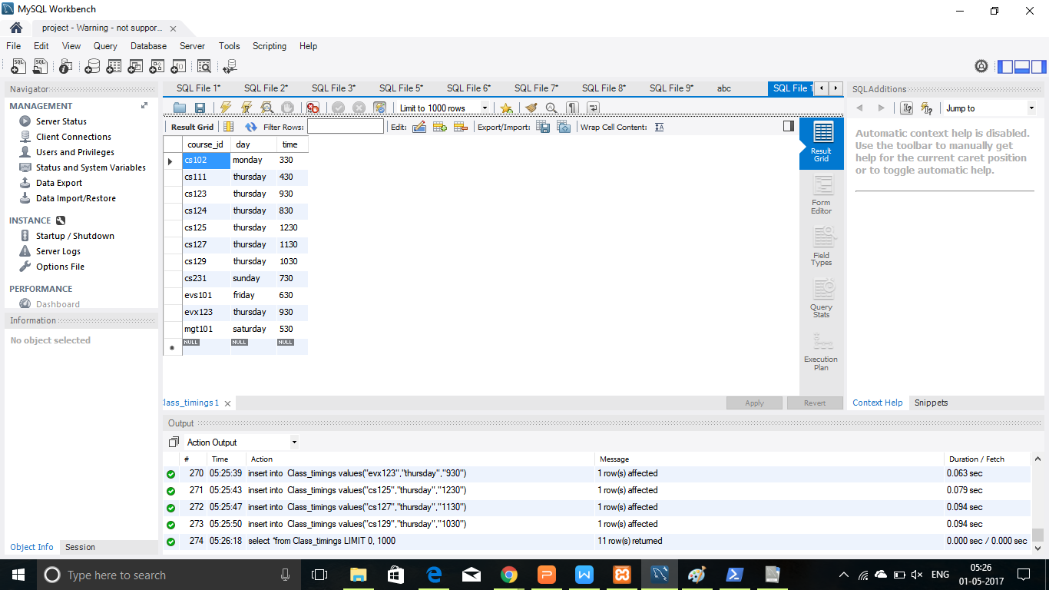

New class_timings(course_id,faculty_name,lecture_hall)



Output:

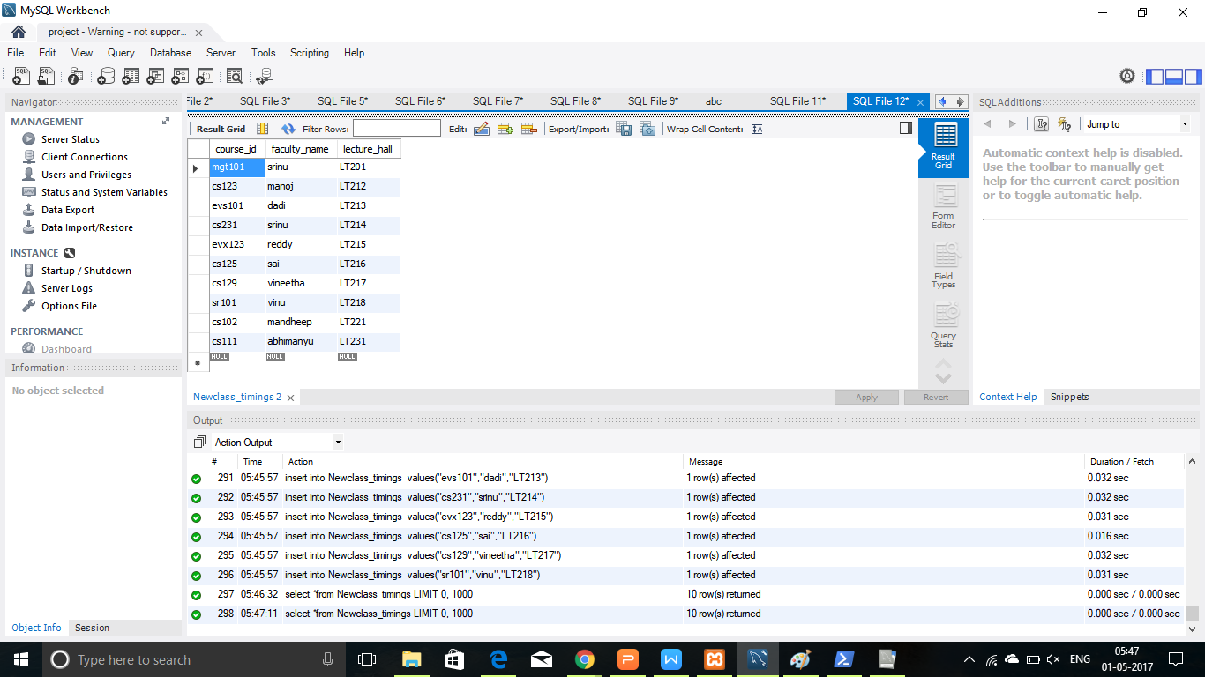

1. Table_textbook

New Textbook(book_name,author_name)

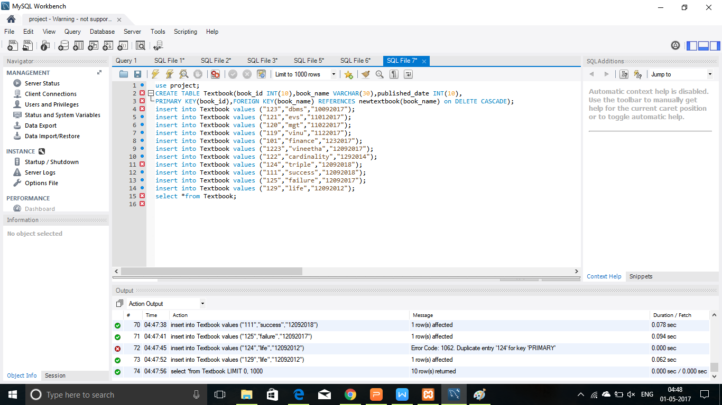

Output:

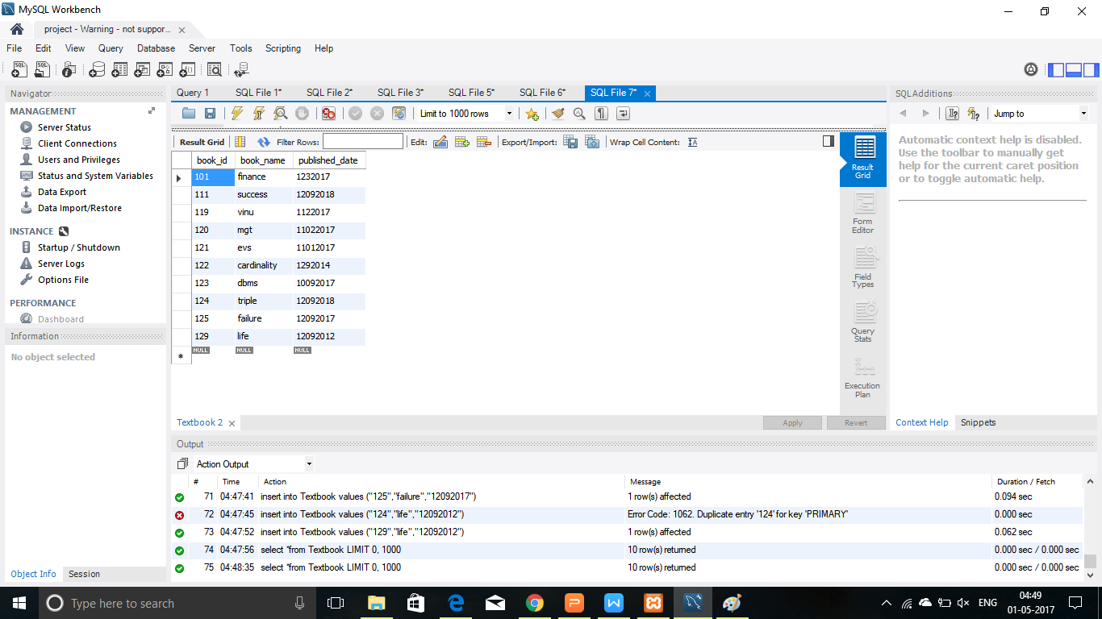

Textbook(book_id,book_name,published_date)

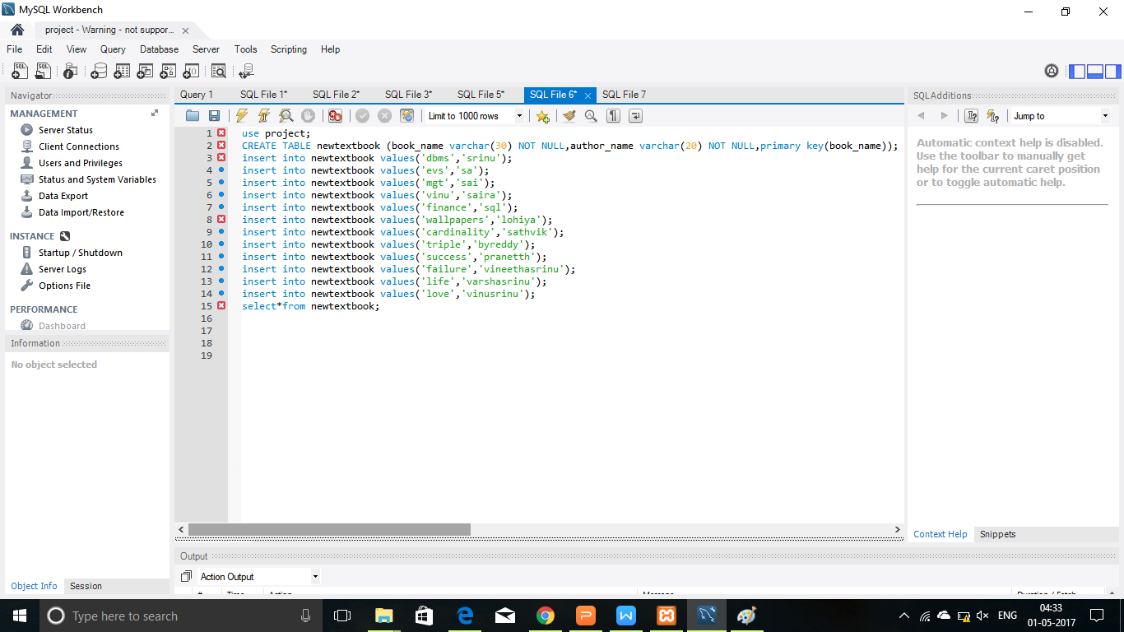

Output: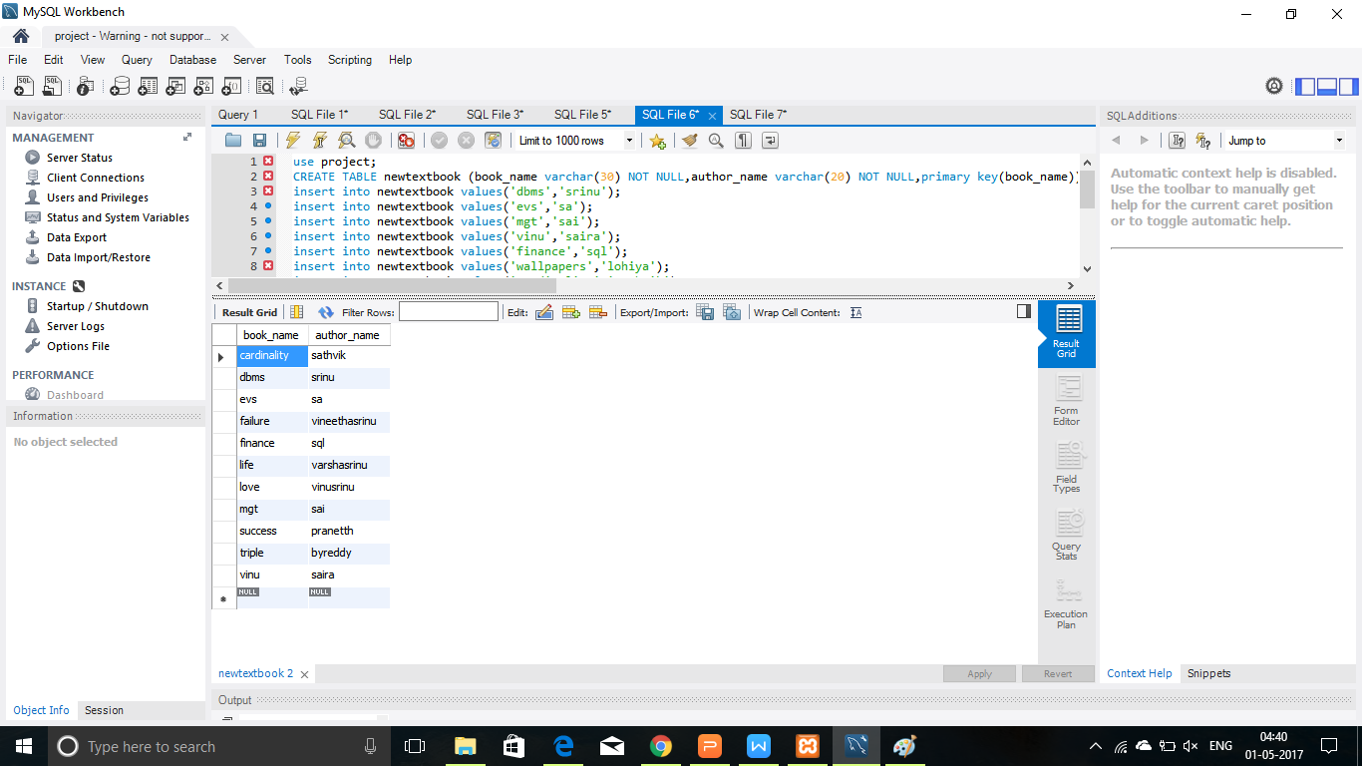

1. Table librarian

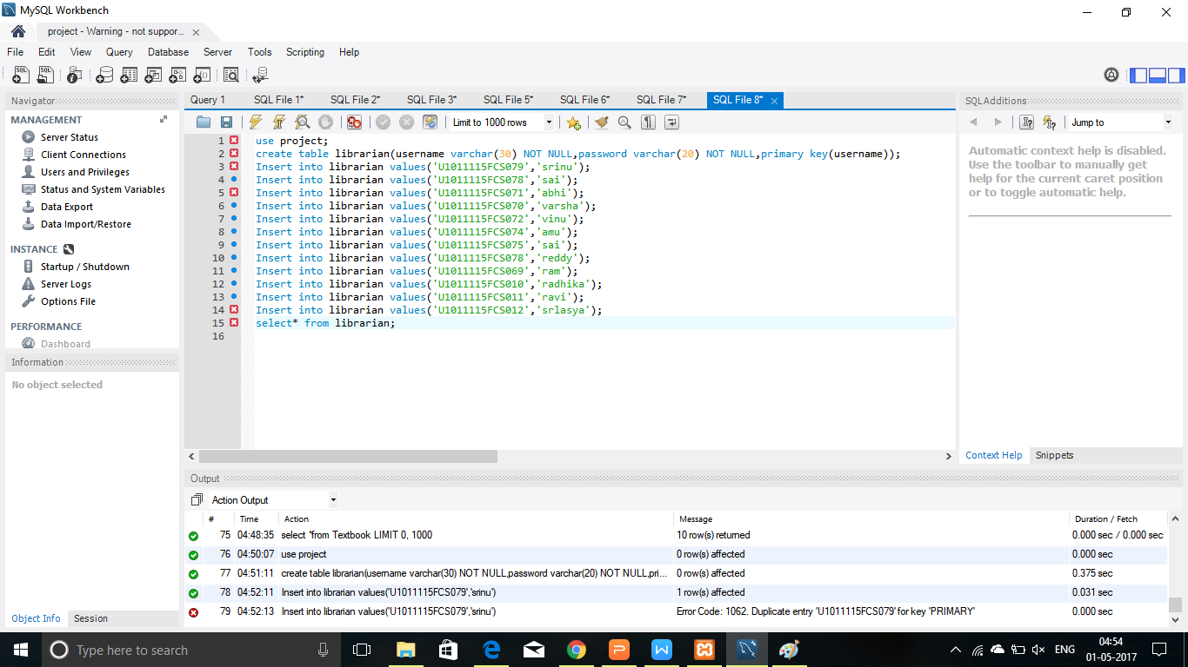

Output:

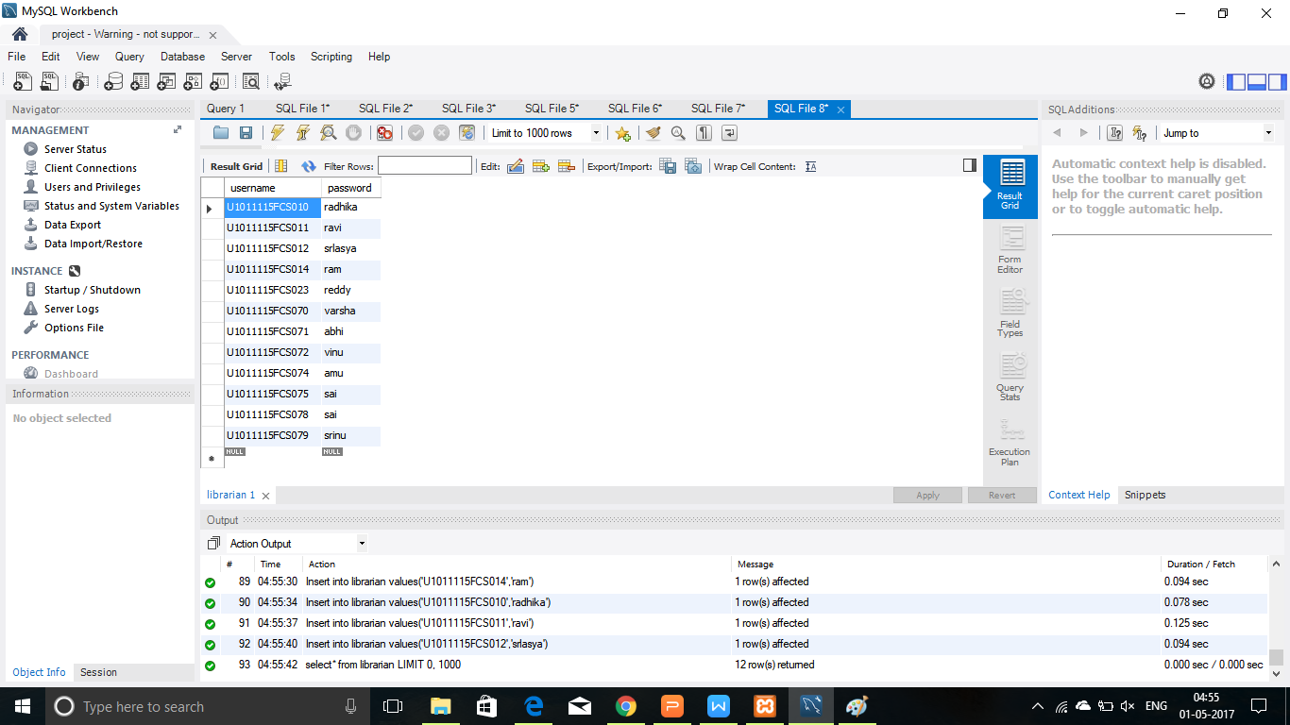

1. Table exams

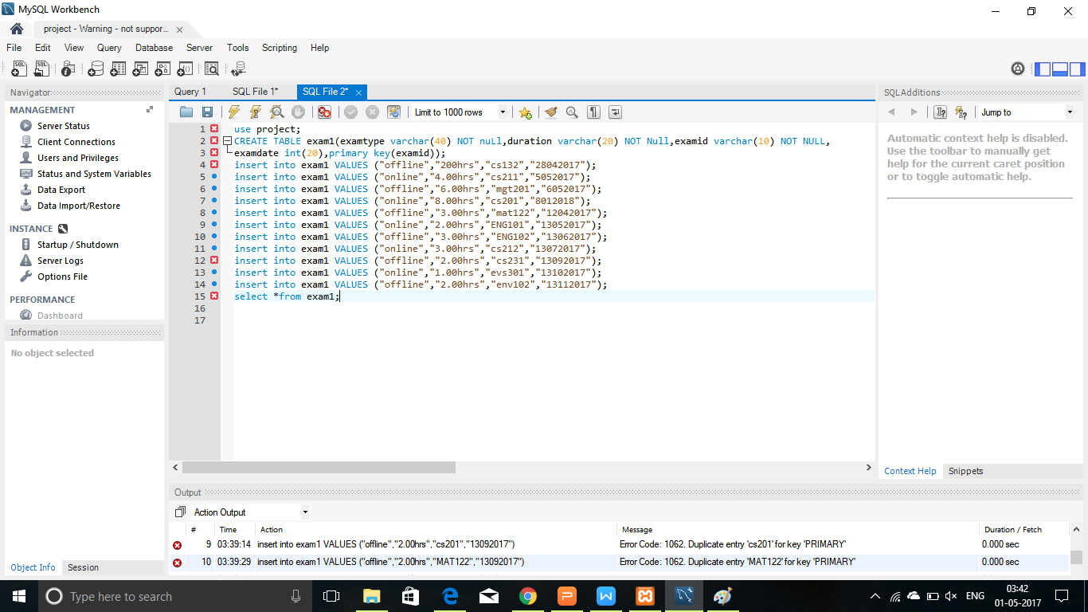

Output:

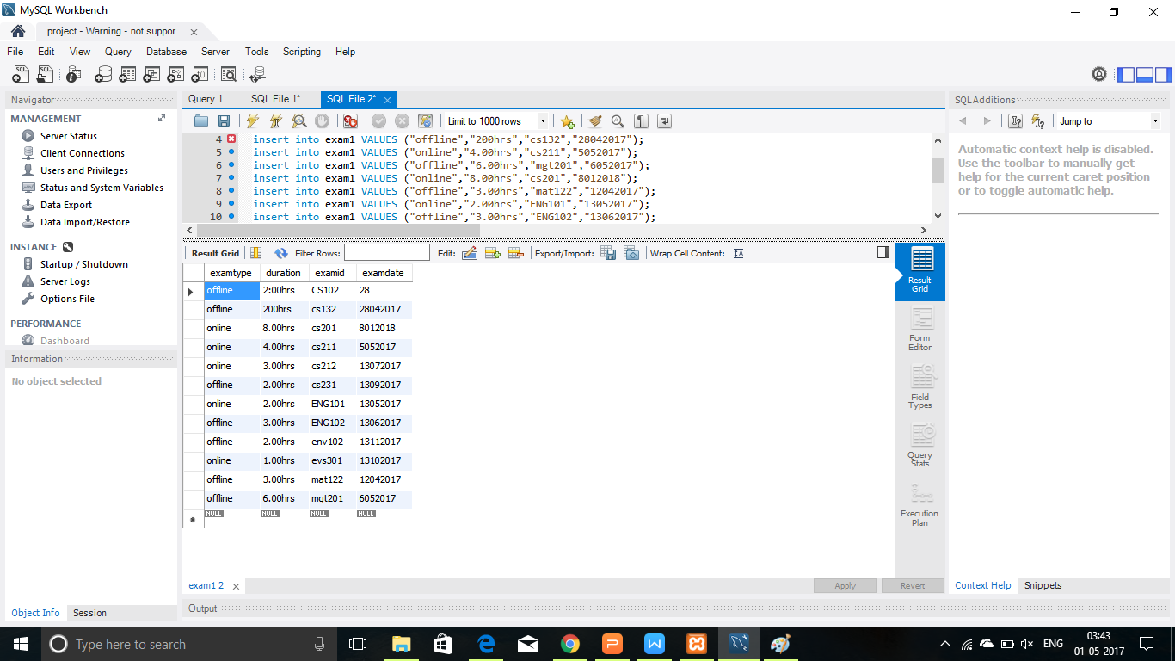

1. Table course

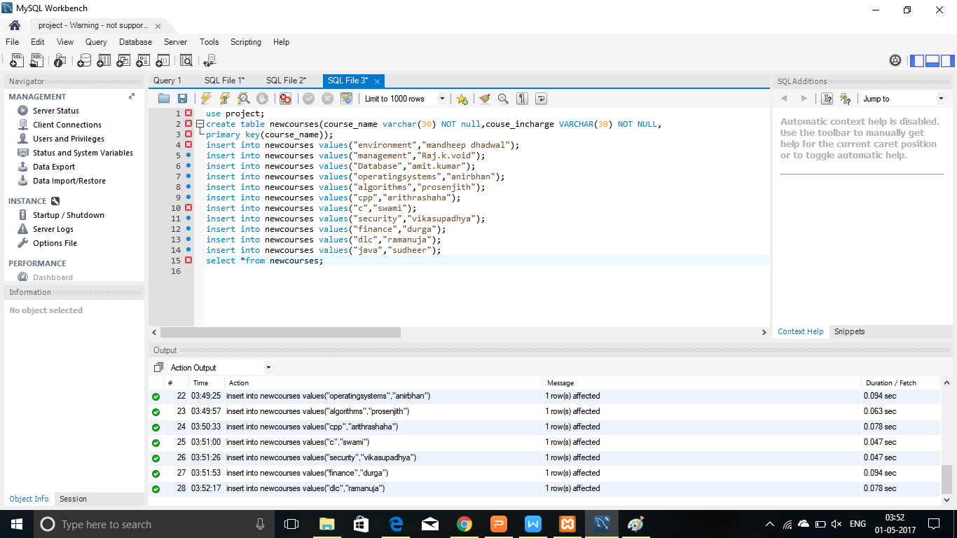

Output:

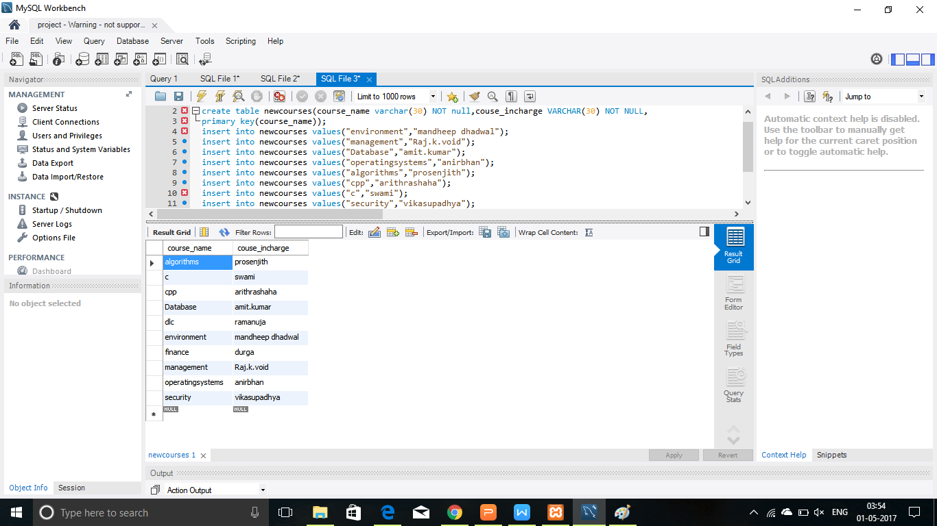

1. Table department

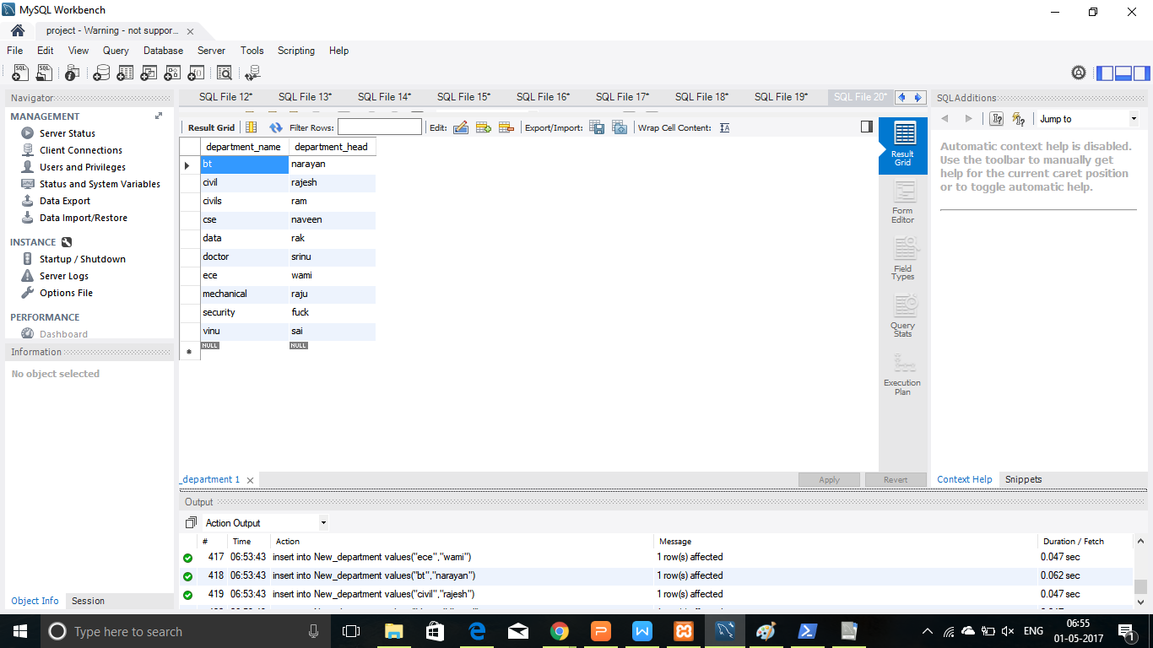

1. Table hostel

Code:

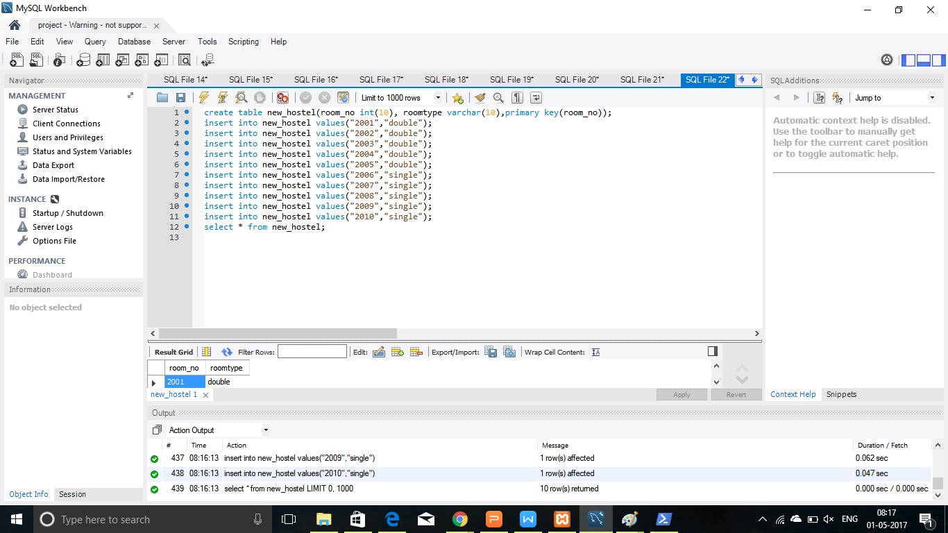

Output:

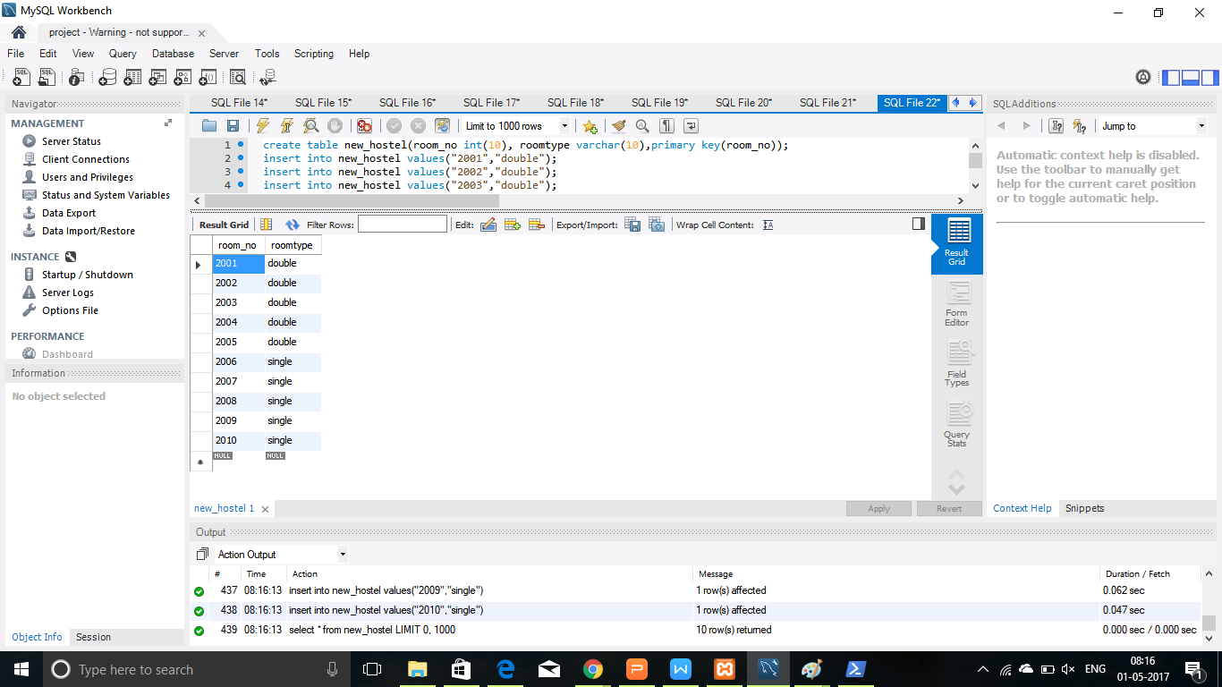

1. Accoun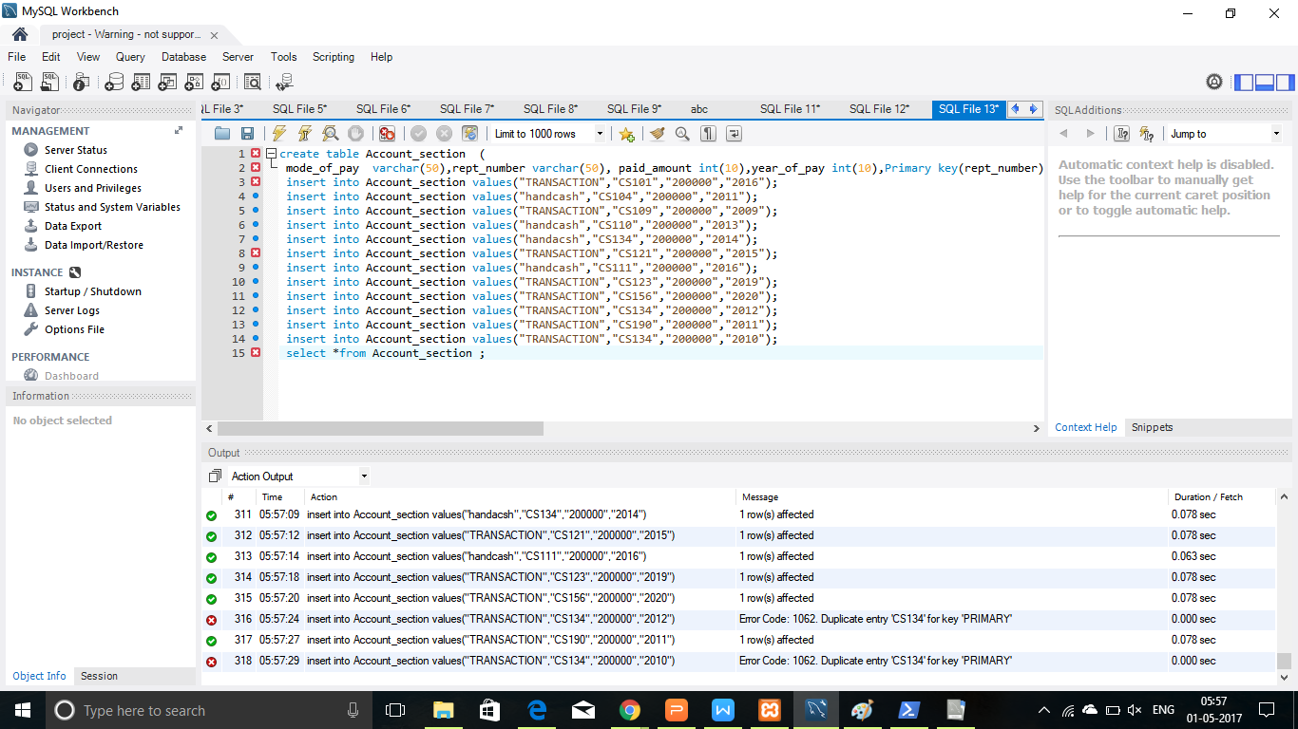

Output:

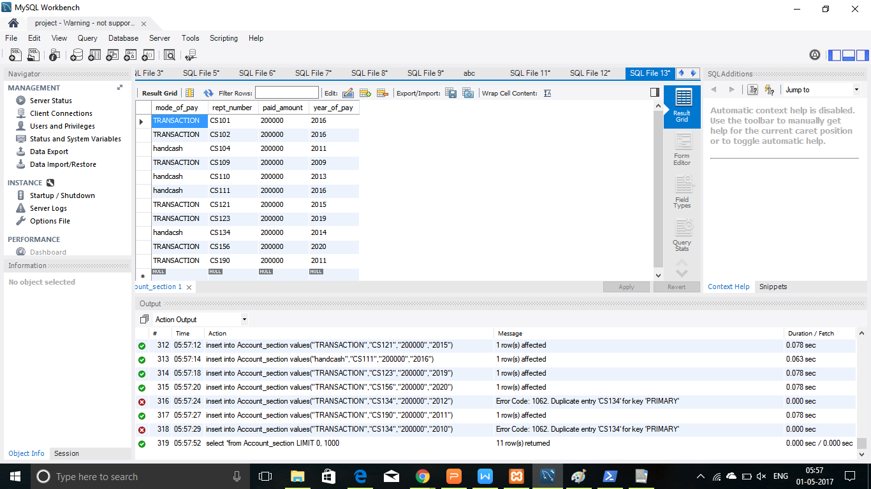

1. Table wardens

Code:



Output:

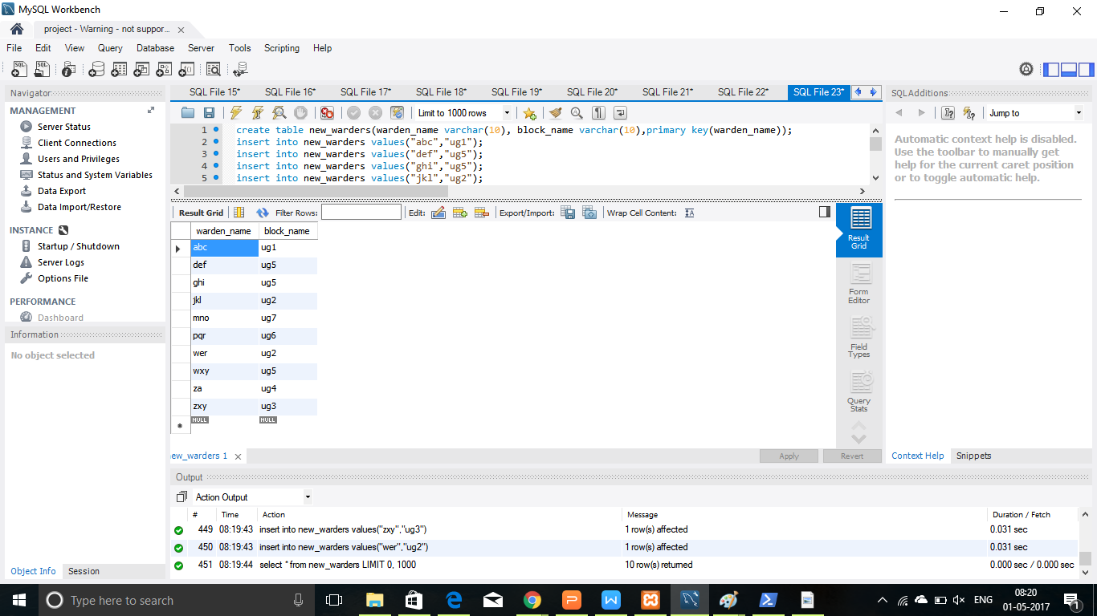

1. table course



Output:



1. Table gatepass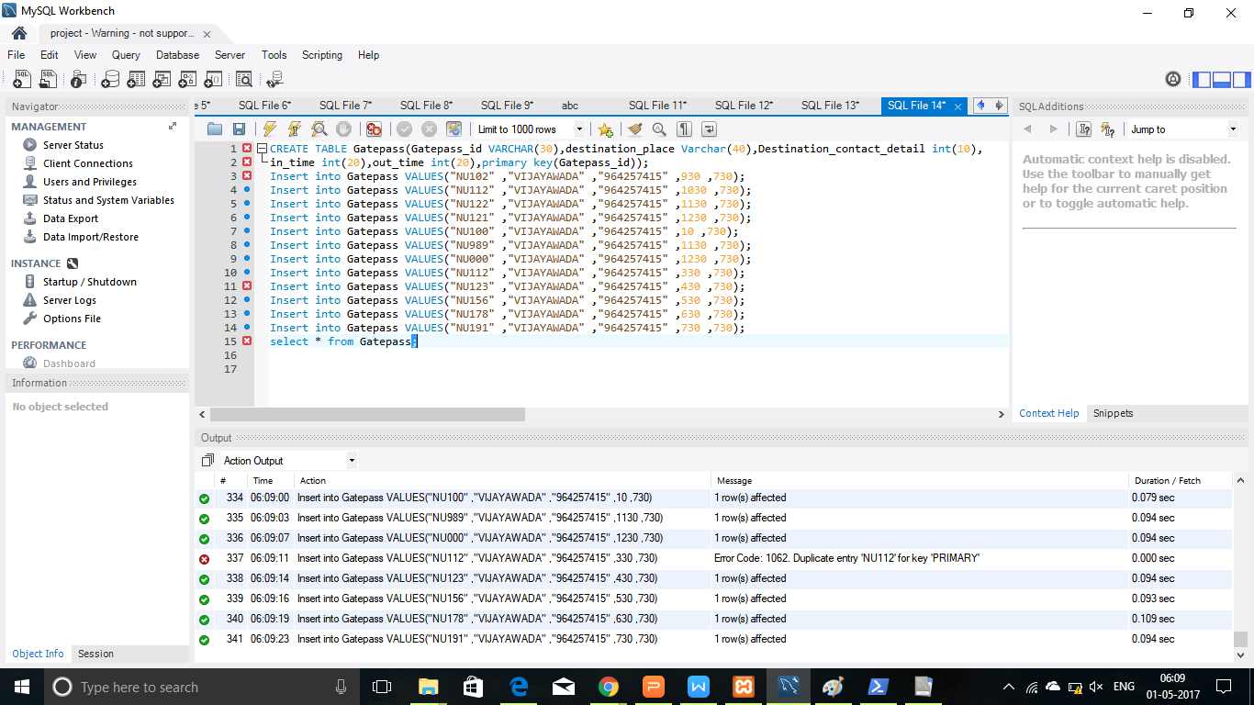

Output:

